Multi-cloud cost management covering AWS, Azure, and GCP
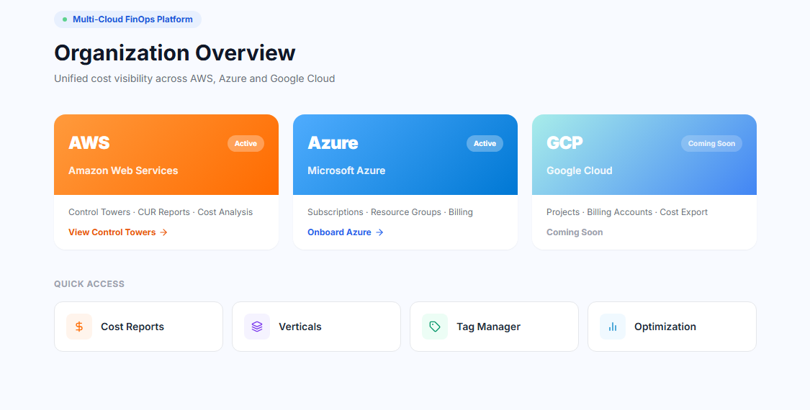
Account-level cost breakdown providing granular visibility into cloud spending across individual sub-accounts with savings plan allocated cost and savings earned
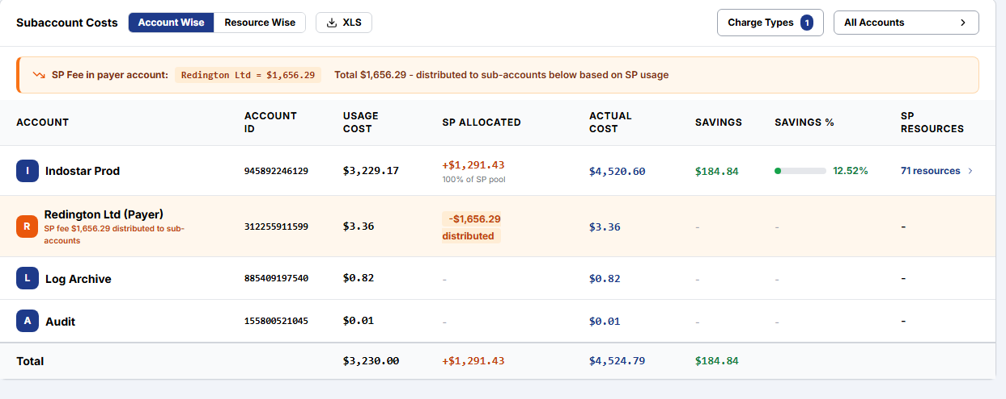

Cost analysis with detailed time-based spending breakdown and savings plan cost for individual resources

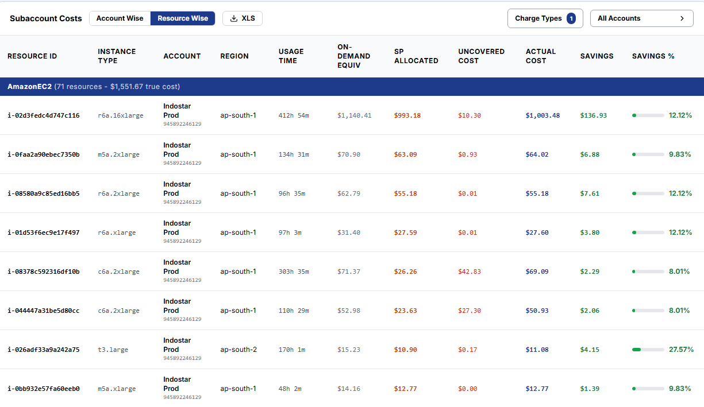

Comprehensive cost breakdown by service, account, and tags enabling multi-dimensional cloud spend analysis

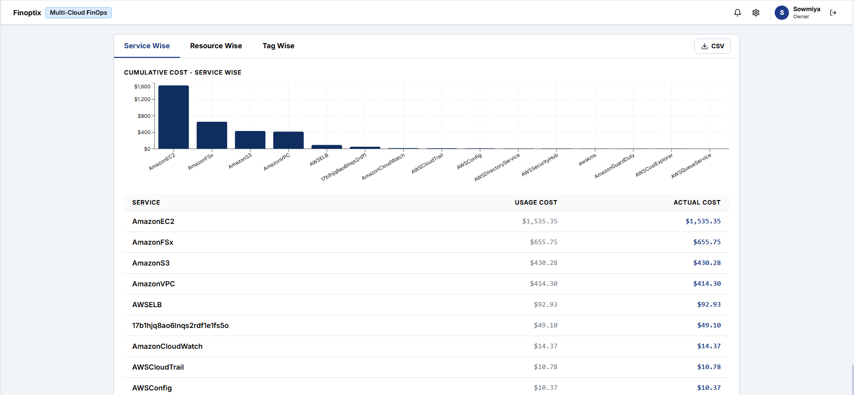

Verticals overview page providing a consolidated cost summary across organizational verticals and with detailed business and owner wise cost
